AI ASSISTED CODING
LAB TEST-4
QUESTION-1
With AI support, construct a Gym Membership Management Database.
• Create tables: Members, Membership_Plans, Attendance_Logs
• Insert sample records into the tables
• Write a query to find members who visited the gym more than 10 times in the past month
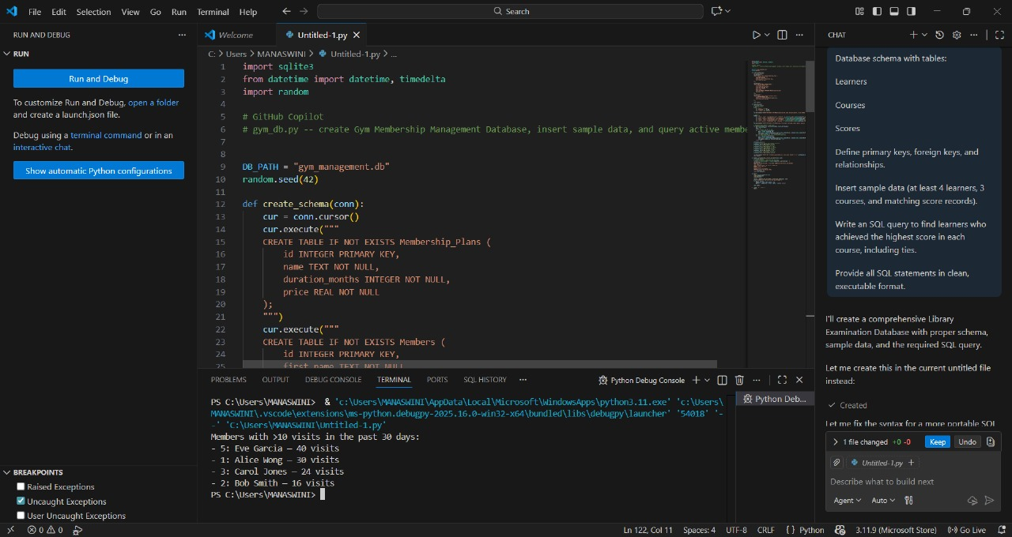
QUESTION-2
Use AI to convert a C++ program that finds the maximum in an array into Python,
and verify that both versions produce the same result for an example array.
